Answer 1 :

GREP command is used to check for the pattern matching in a file.

SYNTAX:
grep [options] pattern files

Options Description
-c : This prints only a count of the lines that match a pattern
-h : Display the matched lines, but do not display the filenames.
-i : Ignores, case for matching
-l : Displays list of a filenames only.
-n : Display the matched lines and their line numbers.
-v : This prints out all the lines that do not matches the pattern
-e exp : Specifies expression with this option. Can use multiple times.
-f file : Takes patterns from file, one per line.
-E : Treats pattern as an extended regular expression (ERE)
-w : Match whole word
-o : Print only the matched parts of a matching line,
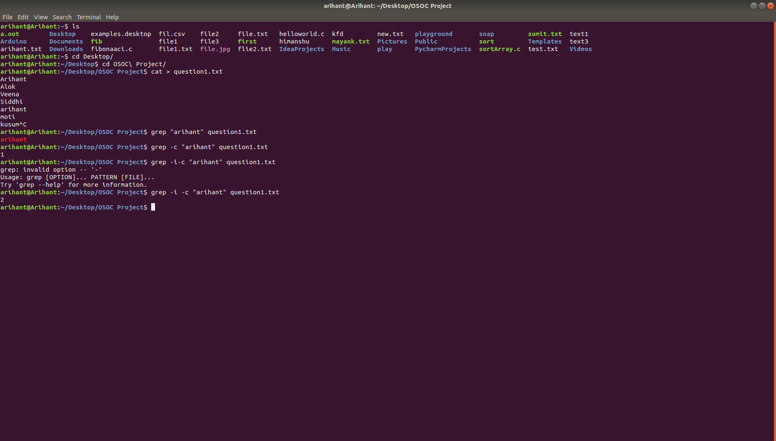

Answer 2 :
There are 3 permission for 3 different level.
Types of permission :
1. r -> Read
2. w -> Write
3. x -> Execute
Types of level :
1. u -> User
2. g -> Group
3. o -> Other
Command to change the permission of the file -> chmod

There are 10 char in file permission
1. first character shows that it is dir -> ‘d’ or file -> ‘-’
2. next 3 shows permission for the user
3. next 3 shows permission for the group
4. next 3 shows permission for the other
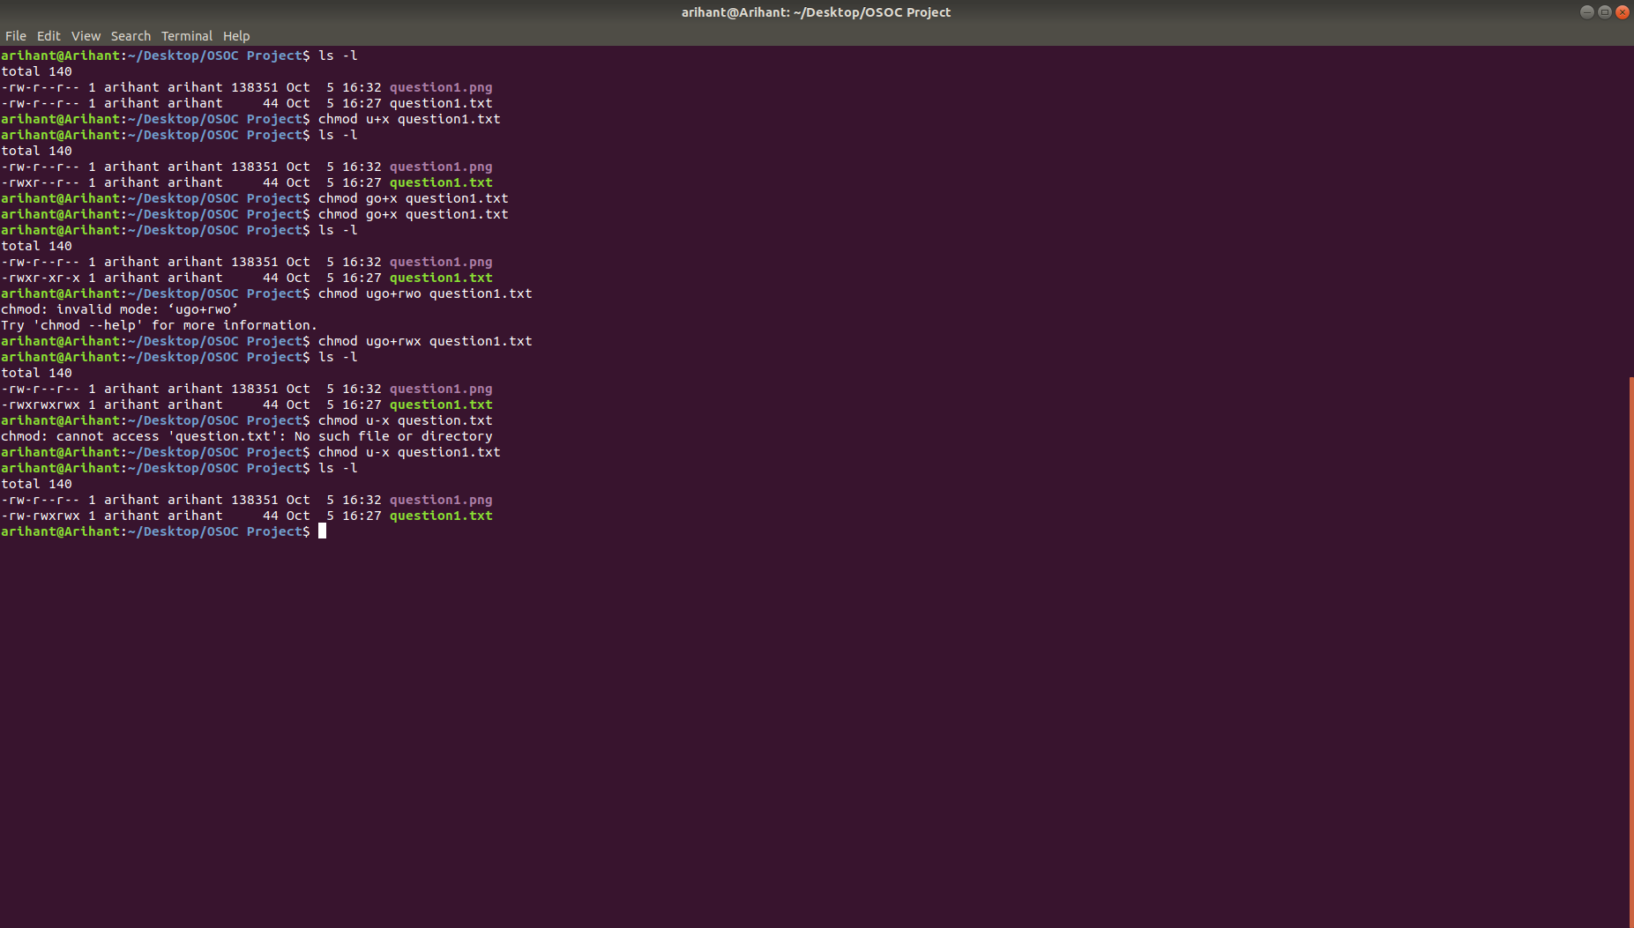
example to add and remove the permissions:
Answer 3 :
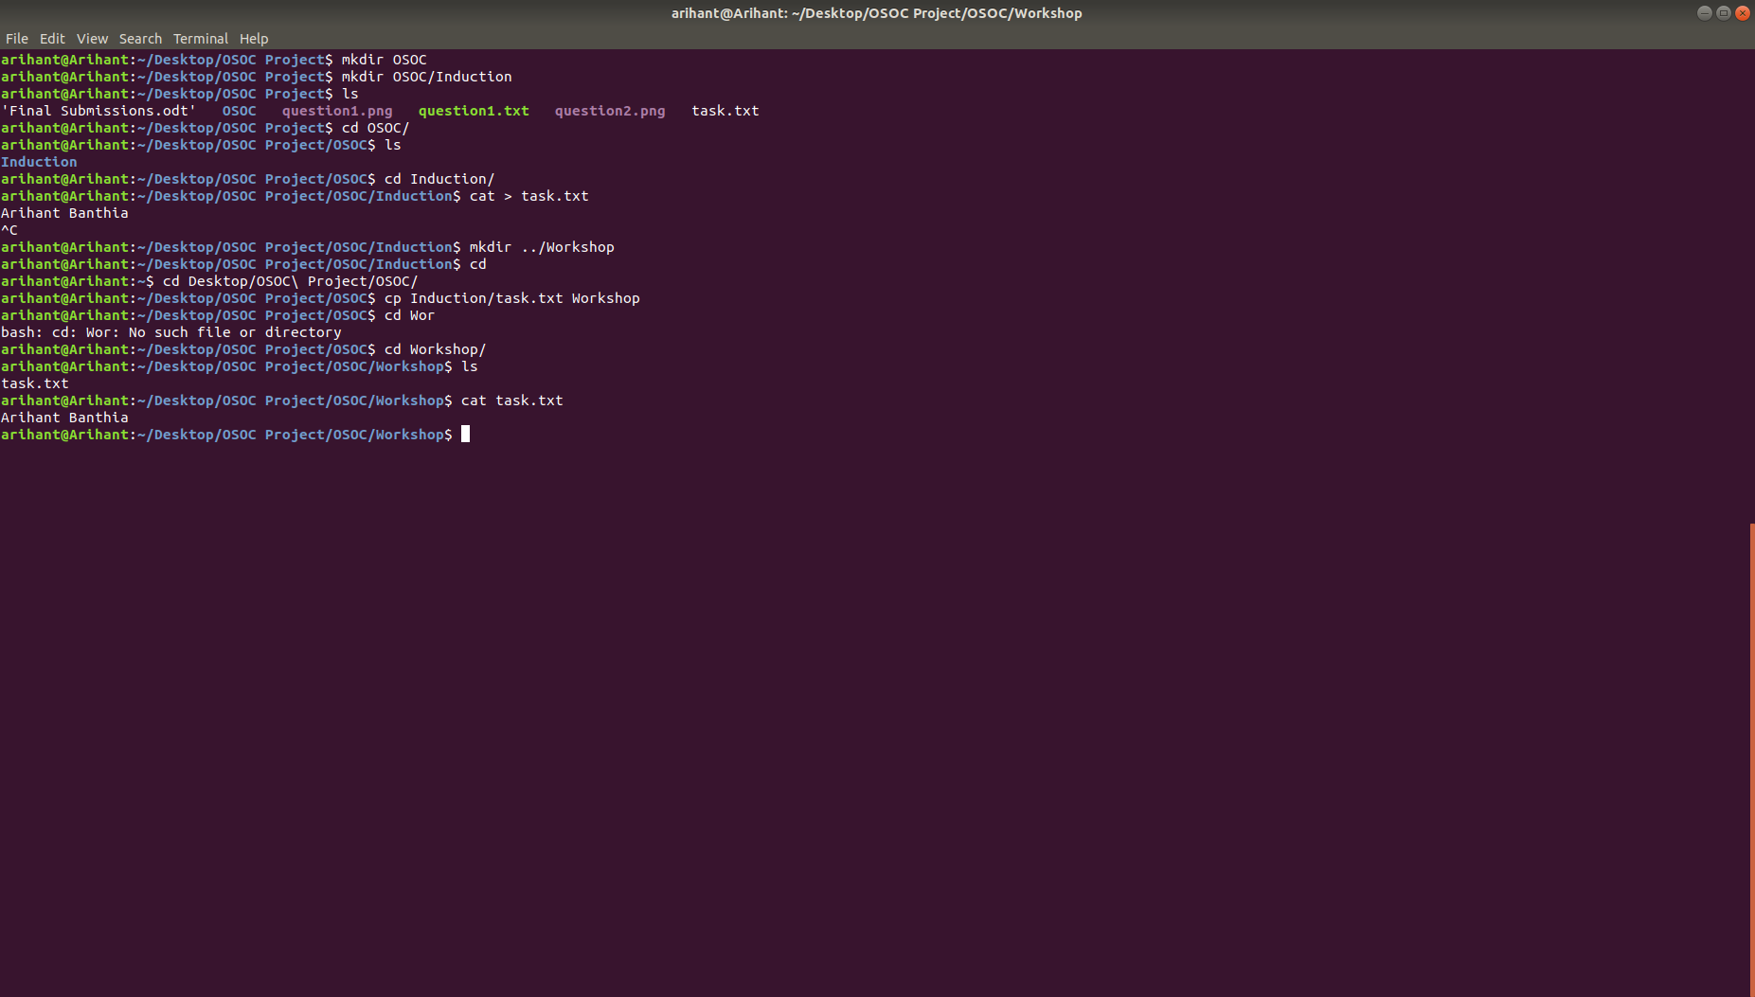

Answer 4 :
To check for the network connected to type route command in terminal.

Answer 5 :
To change the password of any user you must type

$ sudo passwd username
sudo is type for the root user who is the master/Admin of the system
you also must know the password of the user you are about to change

$ sudo passwd -g faculty
by this you can change the password of group faculty

Answer 6:
Branches in git gives a control to us merge the main code with the changed code. As we do braching the main code and newly added code to our project. As you make branches it make harder for the new code to merge with the main/master code. This gives us chance to keep our code clean and secure. It is very usefull in version control as we do not disturb the main code and change the code and make the changes in our project the commit it to main brach.
Therefore our main code always stay as we want it to be.

